Nama : Tegar Prasetya

NIM : 18090131

Kelas : 5D

Praktikum 1

1. Source code

Perkenalan.php -> application /Controllers

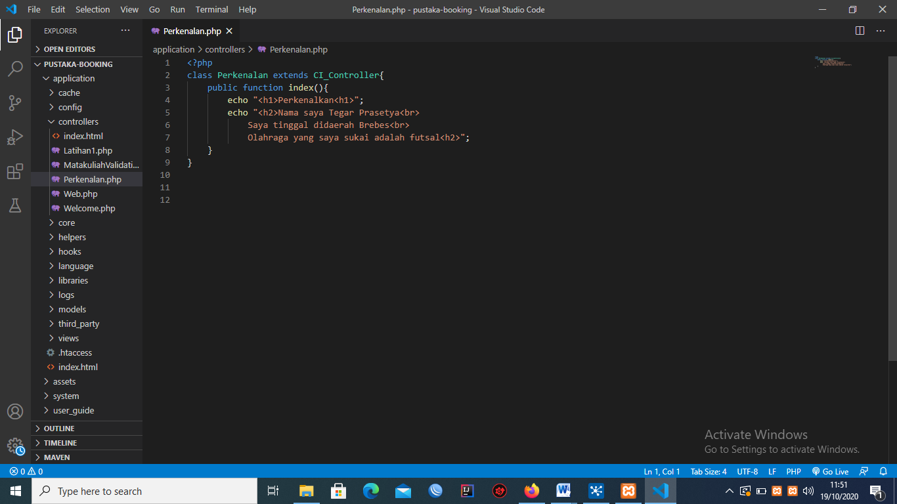

1. Hasil URL

<http://localhost/pustaka-booking/index.php/Perkenalan>

1. Capture Output Program

